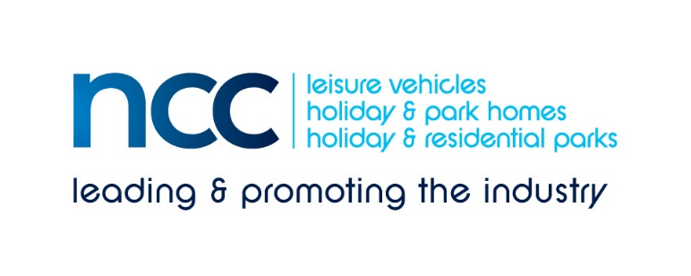
Media release 30 April 2020; immediate distribution
New study reveals how COVID-19 is impacting consumer attitudes to holidays
- Increase in staycationing likely, as shift towards UK destinations is revealed
- Leisure vehicle/caravan holiday home vacations seen as more ‘socially acceptable’
- Spending time with family, going out, and holidaying are the most looked forward to ‘post lockdown’ activities
The NCC (National Caravan Council) has commissioned a new study to track how consumer attitudes are changing towards UK holidays and short breaks in general, and caravan holidays in particular, as a direct result of coronavirus. The quantitative tracking study by Populus* assessed over 2,000 adults, weighted to be nationally representative.
Unsurprisingly, a significant number of people had had their pre-August 2020 holiday plans disrupted by COVID-19. However, two thirds (66%) of consumers whose UK holidays plans had been impacted say they are likely to take UK holidays or short breaks between August and December 2020, (provided the restrictions are lifted before then).
This is a substantially higher proportion than for trips abroad. Of those who were planning to travel to Europe, only 42% are likely to take European trips between August to December; of those planning non-European trips, just 21% are likely to re-book.
As there are more than a million households who own a leisure vehicle (touring caravan, camper or motorhome) or holiday caravan/lodge, the NCC was interested in knowing what attitudes would be to this type of holiday for the remainder of 2020. Seventy percent of UK adults said they perceive a holiday caravan-based UK break as generally socially acceptable. Motorhoming did even better, with 77%, indicating its acceptability. These holiday types were regarded as much more acceptable than, say, a trip to a European city - even in the first six months after restrictions are lifted.
This is extremely important for the UK’s holiday parks industry, which is already gearing up to make re-opening as safe as it possibly can. NCC Director General, John Lally commented: “This result is highly important for our industry. Our holiday parks benefit from rural and coastal locations, away from densely populated urban areas. Units are usually located a minimum of 5m away from each other and enjoy their own services and facilities, which allows caravanners in their tourers, motorhomes or holiday caravans to be independent. Each unit is separate with no shared doors or communal access areas. So, they are more suited to social distancing than many other types of holiday accommodation.”
Looking ahead to 2021 holidays (assuming restrictions are lifted), significant numbers of people still want to take trips next year. With this comes a continuing shift in attitude towards the UK as a destination, compared to pre-COVID-19 travel.
John Lally continues: “Sixty-four percent of consumers are ‘planning’ to take trips in the UK which pre-COVID stood at just 38% - a significant shift. However, this ‘intent’ has yet to be converted! The UK holiday parks industry offers such a wide range of holidays and has great potential to provide freedom, enjoyment, open air activities and time with family. As we emerge from this huge challenge for Britain’s tourism industry, we say “long live the great British holiday.”
Finally, what are most UK adults looking forward to – as well as the great British holiday - after restrictions are lifted? The three top-ranked activities (chosen by 82% of UK adults) are:
- Spending time ‘in person’ with friends and family
- The freedom to go out without thinking about it
- Going on holidays or short breaks
Interestingly, among the lower ranked activities that are ‘most looked forward to’ were:
- Going to the hairdressers
- Bingo
- Love.
Ends
Editors’ notes:
The National Caravan Council (the NCC) is the UK trade association representing the touring caravan, motorhome, caravan holiday home and residential park home industries. It represents more than 550 companies across 850+ different UK outlets, and is the only UK trade association that represents the entire supply chain including holiday/residential parks, dealerships, manufacturers, workshops, and suppliers of specialist services and products.
*The NCC worked with Populus, who run polls on a range of topical issues and is a founder member of the British Polling Council (see www.populus.co.uk/polls). They interviewed a random sample of 2,050 adults online between 22 April and 23 April 2020. Interviews were conducted across the UK and the results have been weighted to be representative of all UK adults.
NB The results are the first wave of a series of research waves checking changing UK consumer attitudes and intentions as the COVID-19 story unfolds. Fuller details of the results are available on request.
Each wave will reflect an increasing consumer awareness about the social and economic steps the country will be taking towards recovery. The findings will reveal how their views are changing, and how this impacts the UK leisure industry.
Press contact: Louise Wood email louise.w@thencc.org.uk tel: 07824 994690

