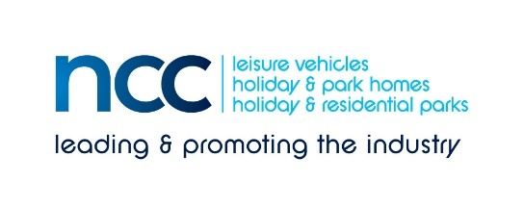
23 June 2020
PRESS RELEASE – immediate distribution
NCC delighted that caravan parks in England can reopen from 4 July as Government confirms further changes to lockdown restrictions
Prime Minister Boris Johnson has announced that from Saturday 4 July, people can now “enjoy staycations in England with the reopening of accommodation sites”. This is understood to include caravan parks and campsites – although all businesses need to adhere to COVID Secure guidelines.
The National Caravan Council (NCC) Director General, John Lally, commented: “This is great news for caravan-related businesses in Hull and Humberside and for the parks industry in England, and not a moment too soon. The NCC has been working hard to explain to Government that the caravan industry – manufacturers, suppliers and park operators – have been struggling since lockdown, with many businesses on their knees.
“Finally, we have the opportunity to unlock the supply chain. We know that interest in tourers and motorhomes has spiked since dealerships were allowed to re-open on 1 June. Local leisure vehicle manufacturer, Swift, has reported significant increases in traffic to its website – particularly from younger people.
“We still need to convert the pent-up demand for products that are ‘socially distanced by design’ into sales. The industry will certainly still need help as nearly three months of prime selling time has been lost – and we are a very seasonally-based industry.”
A meeting has been arranged with Business Minister, Nadhim Zahawi MP, the NCC and Hull and Humberside MPs to discuss specific help for the industry. John Lally concludes: “Thanks to all the MPs who helped the NCC and the industry, and to those businesses who lobbied their MPs tirelessly. We have been given a lifeline.”
Ends
Editors’ notes
The National Caravan Council (the NCC) is the UK trade association representing the touring caravan, motorhome, caravan holiday home and residential park home industries.
The NCC represents more than 550 companies across 850+ different UK outlets, and is the only UK trade association that represents the entire supply chain, including holiday/residential parks, dealerships, manufacturers, workshops, and suppliers of specialist services and products.
There are currently in use in the UK:
520,239 touring caravans
228,035 motorhomes/campervans
250,680 caravan holiday homes

Contact: Louise Wood E: louise.w@thencc.org.uk for more information

